  - ODEON Mine Platform
1.5.1 The platform

With the Mine platform ODEON will operate 1 to 3 mining facilities located in Sweden, Island and Canada. The locations offer green and cheap-as-possible energy to power the graphics cards dedicated to mining. Within this part, we are going to describe some of the technical aspects behind mining (and therefore why there is a need for miners) as well as the financial aspects that follow out of it.

1.5.2 Mining
In addition to the description of mining in the Whitepaper, which mainly focused on mining in general and the miners point of view. The technical paper focuses more on the mathematical concepts behind mining (such as elliptic curves) and aims to give investors a better understanding of the technology.
In order to ensure that the transaction submitted by the blockchains’s users are not malicious, Satoshi proposed a multistep verification with signatures for each block. Miners therefore set up their hardware (initially CPUs, but GPUs developed to be way faster) for the mere purpose of validating these signatures (and of course to ensure that no one spends money they don’t have).
Different cryptocurrencies use different algorithms to validate blocks. In this technical paper, we are going to describe the process of mining itself and the specialities of the Ethereum hash algorithm (Ethhash). For the following examples and showings, we assume rough knowledge about blockchain-typical keywords.
First off, we need to understand how signatures work. Every address on the blockchain (i.e., every user) has its very own private and public key pair as well as an address. In case of Ethereum, a private key looks like
3a1076bf45ab87712ad64ccb3b10217737f7faacbf2872e88fdd9a537d8fe266

These 42-digits-long address now can be generated with the Keccak-256- hash of the public key and taking the last 40 characters of it, which looks like this
0x7e5f4552091a69125d5dfcb7b8c2659029395bdf
Note that the 0x at the beginning just tells that the following numbers are hexadecimal (0-9 and A,B,C,D,E,F as replacements for 10, 11, …) and it is not part of the Keccak-256 hash.

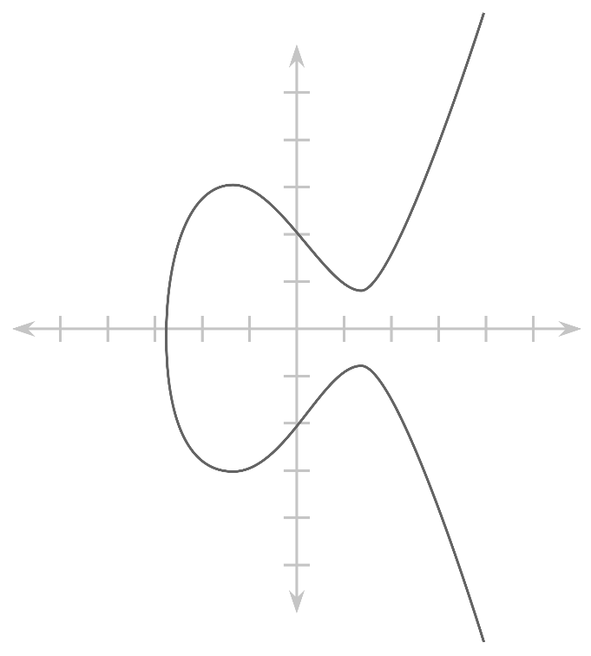
The private key now can be used to sign a transaction and to verify that the sender actually is the owner of the account. The security of the signing relies on elliptical curves.
The general of form of such a curve can be mathematically denoted as
$y^{2}=x^{3}+ax+b$

Consider the following setup:

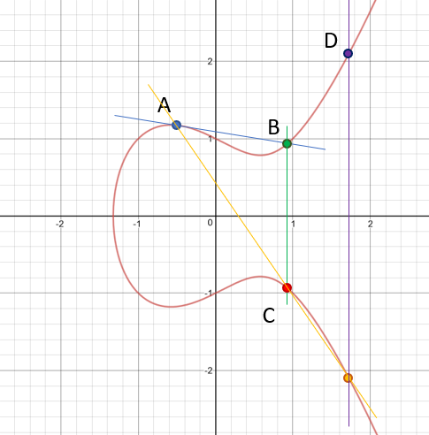
The curve to the left is of the form $y^{2}=x^{3}-x$, meaning we chose a=-1 and b=0.

The point A is the representation of the transaction data and N represents our signing (private) key on the curve.

To follow up on security, elliptical curves are a huge step towards assuring that no one can easily get a private key N from a signature S with known transaction data A.

Now we need to get from the transaction data we want to sign to a correct signature. Elliptical curves as mostly used in cryptocurrencies now use multiplication of A by N, so “data times private key”.

To understand how multiplication (say, 3 x A) works, we need to understand the addition behind it (A+A+A).

For elliptical curve addition, we initially draw a line through two points (usually two different points, for multiplication two times the same) and mirror the intersection to the other side of the x-axis. The resulting point is the sum of the two prior points.
Looking at the graphic, we can get to a multiple of A (for example 2 x A = A+A) by drawing the tangent on the curve at this exact point (“a line through A and A”) and proceeded as described before to get to C=A+A=2 x A. Now we need to repeat this for A and C(=2 x A) to get to D(=3 x A) and so on.
While this might look complicated at first, it’s a rather simple calculation to multiply the data with a private key, but to get from the resulting signature back to the private key is near impossible as there are 2^256 – 1 possibilities for a private key and brute-forcing them is not possible in terms of time and energy required.
Now, having a correctly signed transaction, we can submit it to the Ethereum network and wait for the transaction to be mined and put into a block.

In the next step, the miners validate the correctness of signature. Ethhash comes with a special validation function that takes as input only the signature and the raw transaction data and outputs “TRUE” for a correct signature and “FALSE” for a malicious. The complexity is rather simple. Instead of trying to brute-force a solution, it can be compared to finding prime factors of a large number. Remark: It does not work like prime numbers, this example just demonstrates complexity.
Say, we have the numbers 11 and 7 – both prime. If we communicate their product 77 to other people, they won’t initially know those both primes and have to calculate them. If we now give them one of the two primes, they can just divide the product by it to receive the other prime. Usually these two primes have at least 150 digits each.
Breaking this example down to Ethhash, we have a known prime, the transaction data. we also have the product of these primes, namely the signature. Now we can divide the signature by the transaction data and hopefully get the public key, in which case the signature is valid.

To effectively solve a block – that means putting together multiple transactions and finding a common hash for all of them – miners are required to solve complex mathematical problems. For simplicity, they can be compared to brute-forcing. If a block has, e.g.,10^18 possibilities for the hash to be, and a mining facility delivers a hashpower of 10^12 H/s (=1 TH/s), it would take 1.000.000 seconds or roughly 11d12h to try every single possibility (worst case for finding a single solution). However, these problems leave a certain difficulty underneath the level of finding a single correct hash. We might want to find 1 of 1.000 correct solutions to the problem, leaving an average of 1.000 seconds or 16min40s for a block to be solved.

This validation of signatures as well as the putting-transactions-into-a-block is essentially what mining is all about. However, to not make it easily for malicious people to validate their own fake transactions, the concept of blockchain has a plan to hinder these people: making it expensive to validate.
Whilst the validation is not as hard as brute-forcing, it still takes a lot of calculational power to solve a block. The expense here is the energy required to operate the hardware. The motivation to have a secure payment network is what drives the price up, because without reaching the minimum operational cost as mined ETH, the miners wouldn’t mine.
This is where ODEON chimes in and demonstrates a concept of green yet efficient mining to secure the network and provide investors with participation in doing so by contracting hashpower.

1.5.3 Potential hardware

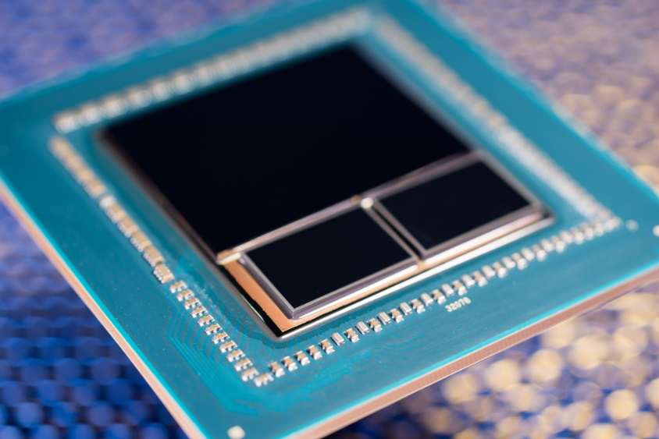
As potential mining GPUs, we decided to choose RX Vega 56 and RX 580 out of the offerings of AMD.
Let’s first dive a little into some of the specs of each graphics card and expand by mining-relevant values.

AMD Radeon RX Vega 56

Process size | 14 nm
Transistors (bn) | 12.5
Core clock (MHz) | 1156
Memory size (MB) | 8192
Avg power draw mining (W) | 190
Ootb ETH-Hashrate (MH/s) | 31.0
MH/s per Watt | 0.16

AMD RX 580

Process size | 14 nm
Transistors (bn) | 5.7
Core clock (MHz) | 1411
Memory size (MB) | 8192
Avg power draw mining (W) | 175
Ootb ETH-Hashrate (MH/s) | 25.0
MH/s per Watt | 0.14

Notably, these are the optimized numbers we found tweaking the graphics cards. Most optimizations made it possible to increase the megahashes per Watt by 20-30% (23% at average).
Considering the most relevant number in terms of profit (MH/s per Watt), the RX 580 is more profitable to mine with over a long duration. However, the lack of availability of the GPU makes it hard to gather enough RX 580s for a single fully functional mining facility in our design (25.000 GPUs). RX Vega 56s are available in greater numbers as we could barely order any RX 580s at the moment. A big role in the choice of RX 580 and RX Vega 56 also was the selling price in many years in relation to the buying price now. As described more precisely in the White Paper, the comparison of multiple graphics cards yielded the highest revenue for customers with these two.
Depending on their availability, we plan to build up to three facilities, each with 15.000 RX Vega 56s or with 25.000 RX 580s.

1.5.4 Financial aspects
The energy cost per day was calculated as follows:
Cost_{($/day)} = E_{(kWh/day)} × Cost_{(cent/kWh)} / 100_{(cent/$)}

Currently, we can obtain power in our planned mining facilities for less than 5ct/kWh. The calculations from the Whitepaper still hold true:

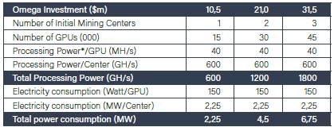
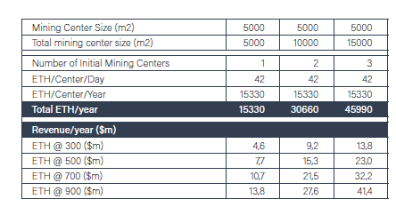
Cost per day was calculated as follows
Cost_{($/day)} = E_{(kWh/day)} × Cost_{(cent/kWh)} / 100_{(cent/$)}

Based upon the graphics cards we chose and the amount of these we want to operate, each of the mining centers will, as denoted in above figure, consume 2,25MW of energy while generating more than 15.000ETH per year. Considering energy considerations of around 5ct/kWh, ODEON needs to spend more than a hundred thousand dollars (112.500$) per year yet alone for electricity. The projected revenue is - even for a low ETH-price – well in the millions. A single GPU is estimated to generate $ 2,10 per day, which means that 15.000 will generate roughly $ 31.500 per day or $ 11,5m in a single year.
More precise financial calculations can be found in the Whitepaper released shortly before.

